Acceptance Test

ID – 11

1. Number from 1 – 9 is inputted

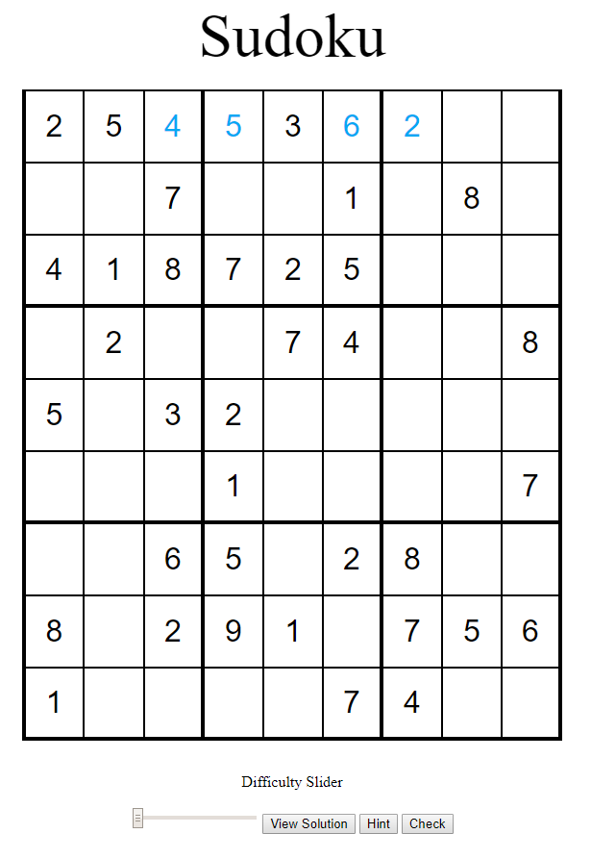

1. Change the entry to different numbers

